Home Page:
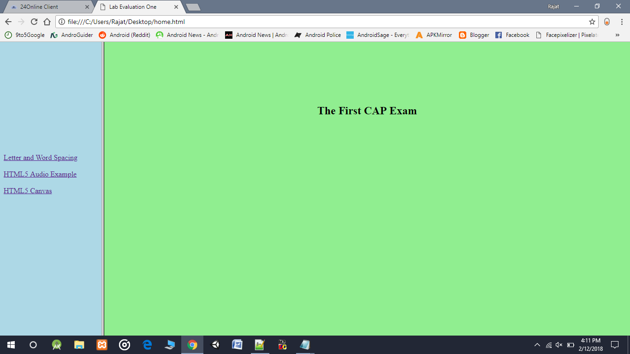

<html>
<head>
</center>
<title>Lab Evaluation One</title>
<frameset cols="220,*">
<frame src="mnu.html"/>
<frame src="main.html" name="main_page"/>

</head>
</body>
</frameset>
</html>
Audio Page:
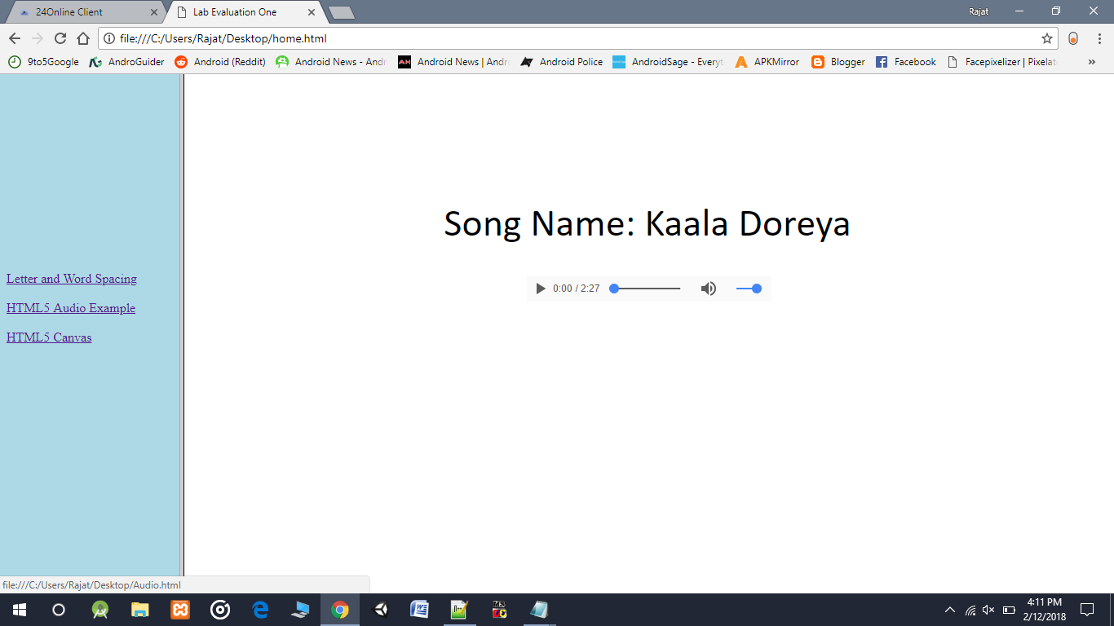
<html>
<head>
<body>
<center>
<br><br><br><br><br><br><br><br>
<font face="Calibri" size="10px">Song Name: Kaala Doreya</font>
<br><br><br>
<audio controls>
<source src="D:\Songs\Kaala Doreya.mp3" type="audio/mp3">
</audio>
</body>

Letter Spacing Page:
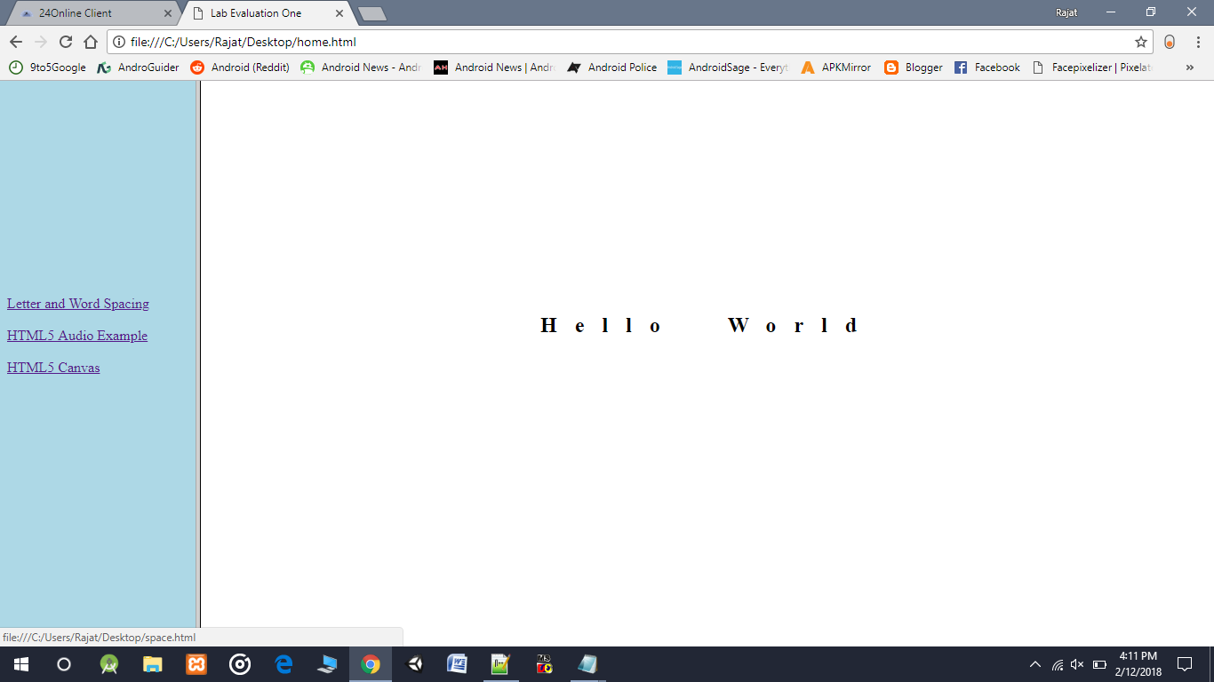
<html>
<head>
<style>
h2
{
word-spacing: 30px;
letter-spacing: 20px;
}
</style>
</head>
<body>
<center>
<br><br><br><br><br><br><br><br><br><br><br><br><br>
<h2>Hello World</h2>
</center>
</body>
</html>

Canvas Page:
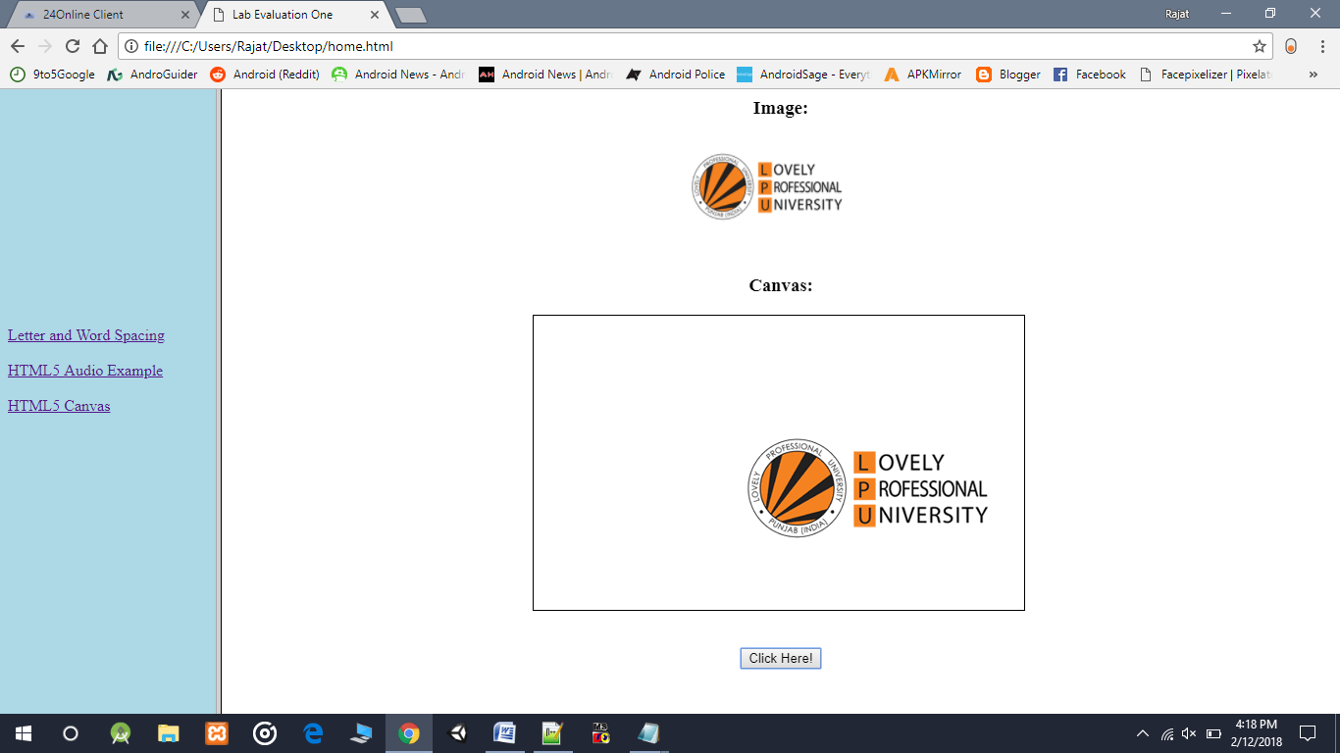
<html>
<body>
<center>
<h3>Image:</h3>
<img id="lpu" src="C:\Users\Rajat\Downloads\download.png" width="200" height="100">
<br><br>
<h3>Canvas:</h3>
<canvas id="cnvs" width="500" height="300" style="border:1px solid black;"></canvas>
<br><br>
<p><button onclick="canvas()"> Click Here! </button></p>
</center>

<script>
function canvas()
{
var c=document.getElementById("cnvs");
var ctx=c.getContext("2d");
var img=document.getElementById("lpu");
ctx.drawImage(img,200,100);
}
</script>
</body>
</html>

